Jenkins Task-03
1. Create one Jenkins job using the below code and create three stages.
- stage1: Git clone to download the source code.
- stage2: Sonarqube Integration to check the quality of code.
- stage3: Slack Integration to send the alerts to slack.
- Source Code: https://github.com/betawins/VProfile-1.git
Step 1: Clone the given repository:
On Jenkins console, create new job and configure with git repo URL.
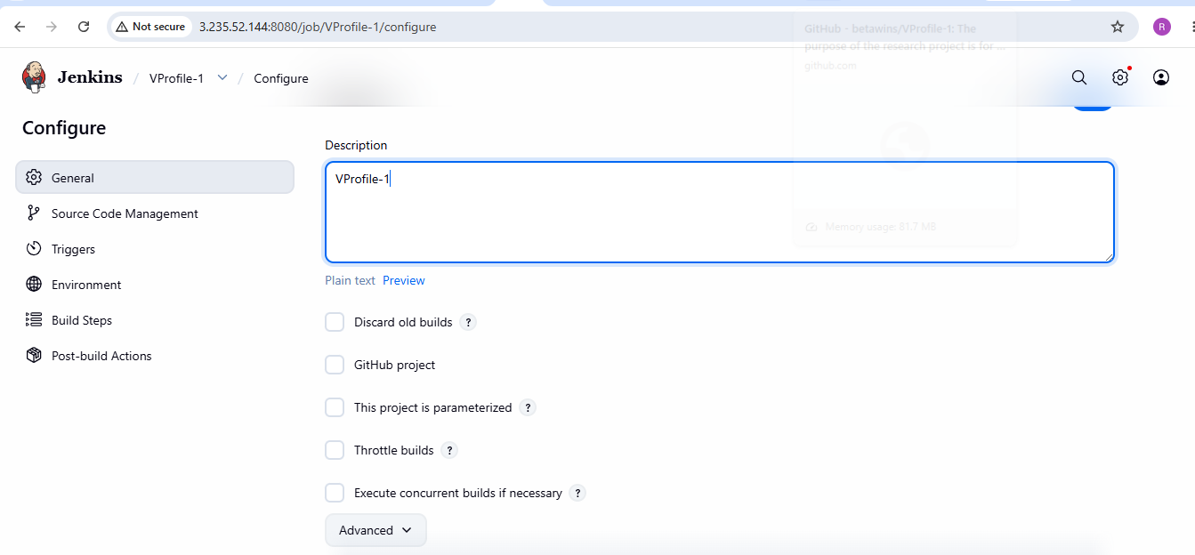Then clicked build now and checked for the console output
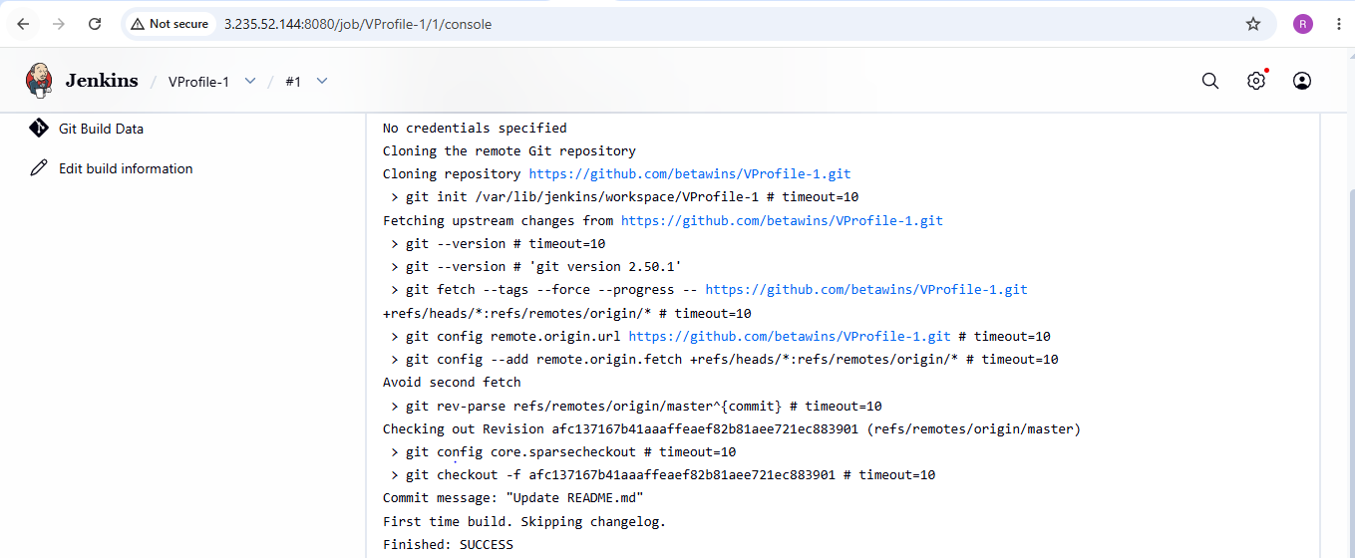

Also verified the clone on Jenkins server and see the code related to repository is cloned successfully
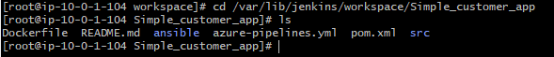
Step 2: Sonarqube integration
1.Launch new instance named Sonarqube with capacity m7i-flex.large and volume 20 Gib.
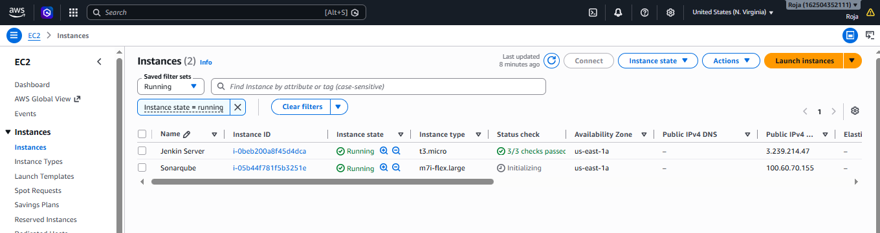
2. Connect to Sonarqube instance and install java
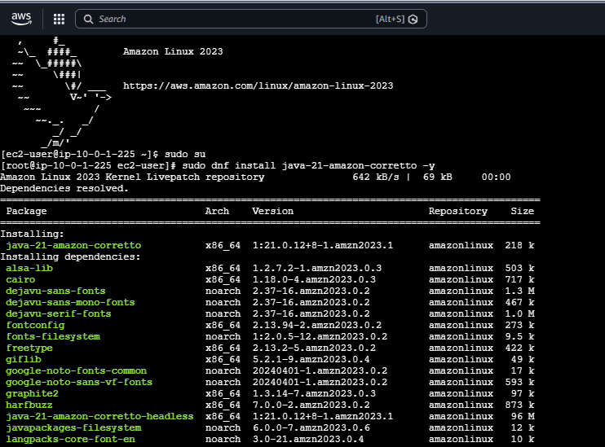
3.Update packages
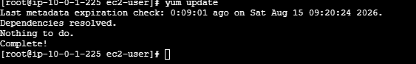
4.Now download rpm packages for Mysql 5.7
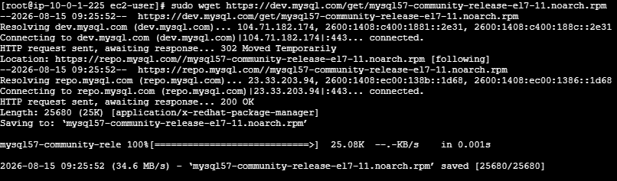
5.Install MySQL 5.7 Community Repository on an RPM-based Linux system
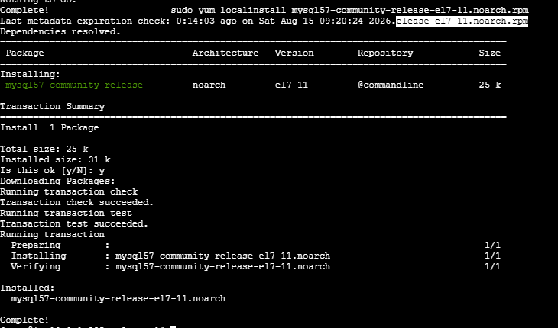
6.Import Keygen
7.Now install Mysql
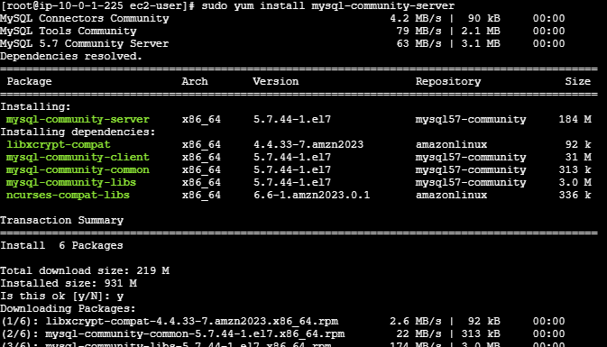
8.Start Mysql service, check status to see if its running and also check if port is listening
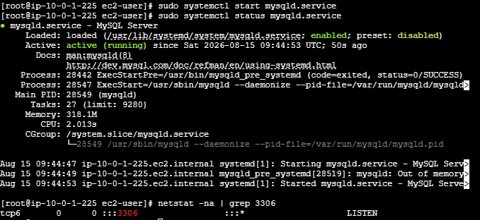
9. Configure MySQL Root password, we see default MySQL root password. Copy this password
10.Login to MySQL database using this password.
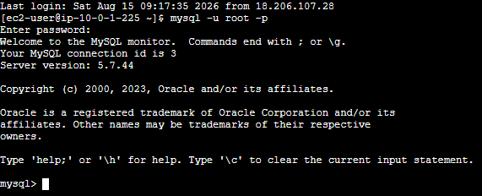
11. Change default password and exit from the database
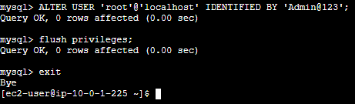
12. Now again try to login to Database using new password and was able to login to database successfully.
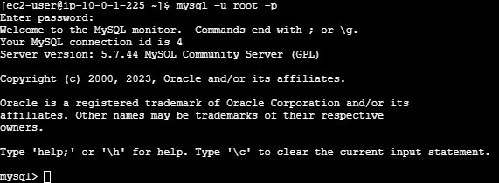
13. Exit out of database change directory to opt and install sonarqube-26.1.0.118079 using
sudo wget https://binaries.sonarsource.com/Distribution/sonarqube/sonarqube-26.1.0.118079.zip Unzip the file and rename it with sonar and verify it in the list.
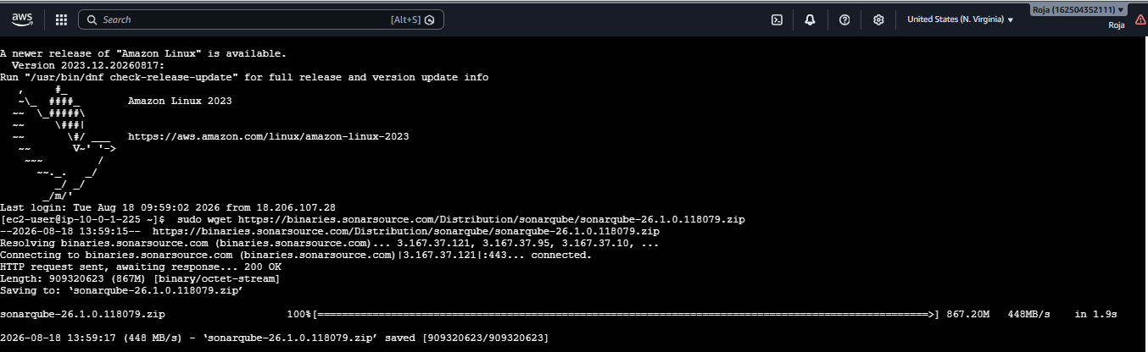
14. Again login to MySQL database and create one database with name sonar
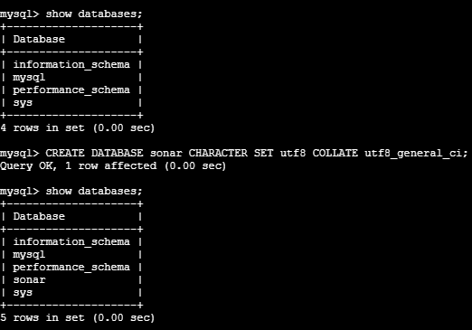
15. Now create 2 users one for remote and one for Local and grant permissions to the users and verify the users. Here we find 2 sonar users i. e one for local and one for remote
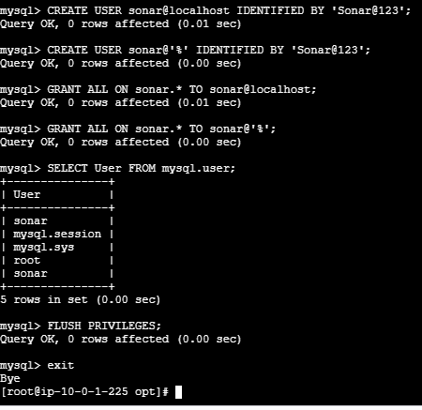
16. Edit sonar properties file to uncomment and provide required information for below properties.
- File Name: /opt/sonar/conf/sonar.properties
- sonar.jdbc.username=`sonar`
- sonar.jdbc.password=`Sonar@123`
- sonar.jdbc.url=jdbc:mysql://`localhost:3306`/sonar?useUnicode=true&characterEncoding=utf8&rewriteBatchedStatements=true&useConfigs=maxPerformance&useSSL=false
- sonar.web.host=`0.0.0.0`
- sonar.web.context=`/sonar`
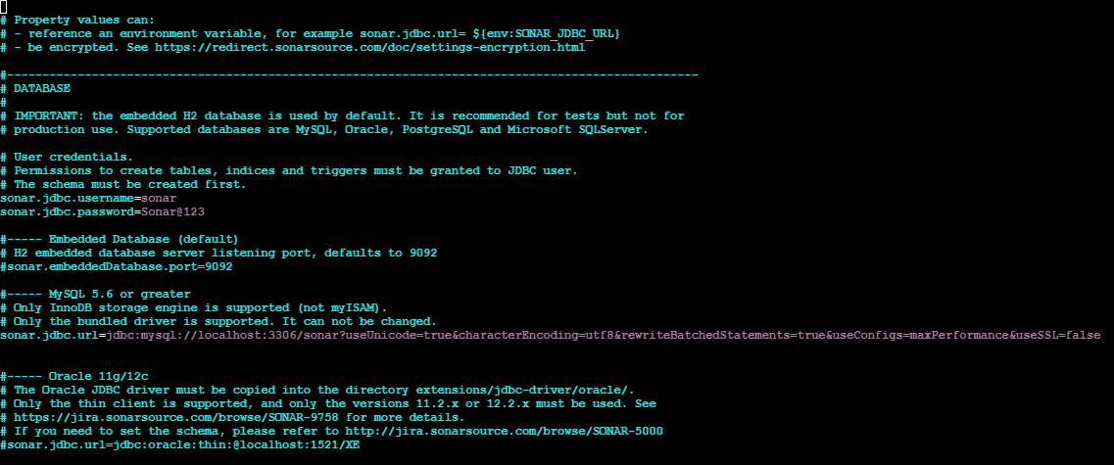
Start Sonar:
- Go to /opt/sonar/ and see the list of files using ls. We can see bin folder.
- Enter into bin folder and ls, linux –x86-64 folder is listed. Now enter to that folder and ls. We see sonar.sh listed.
- Now execute this file using ./sonar.sh start. We see that it failed to start.
- This is because root is having ownership and we are trying to execute it from ec2-user so now we have to change the ownership from root to ec2-user and then try to execute and sonar will start.

Now with the PublicIp and port number 9000 with prefix as /sonar and access sonar in browser
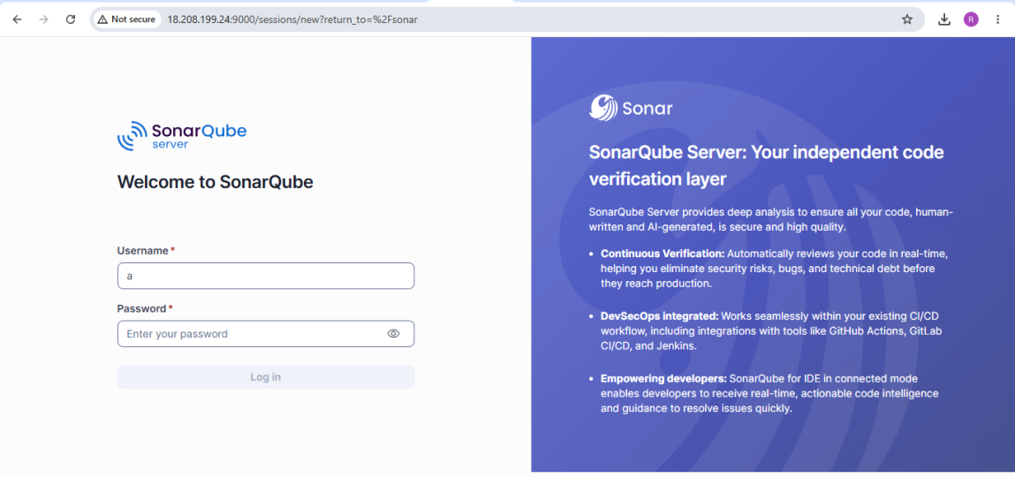
Now Setup Sonarqube plugin in Jenkins to integrate with sonarqube
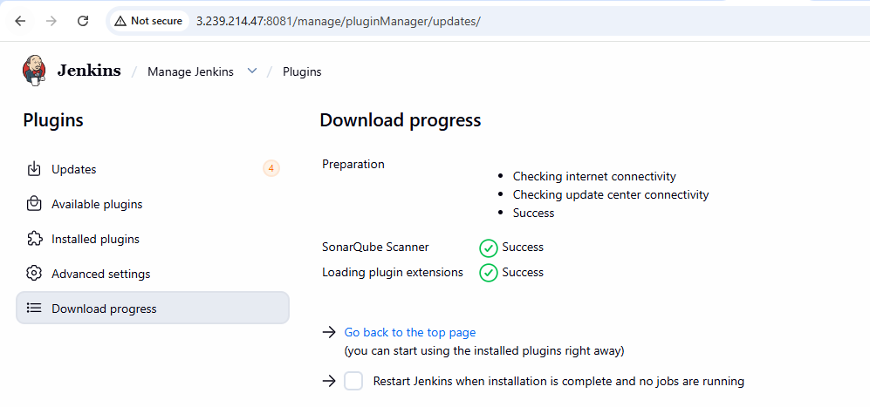
Generate authentication token in Sonarqube server by going to Admin, My account, security
Give the name and click on Generate Token.
It generates a token copy it and paste it in Jenkins configurations.
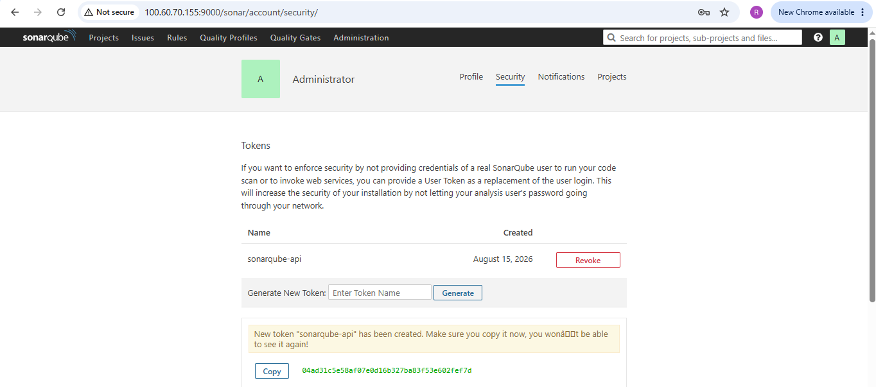
Create credentials in Jenkins by goings to credentials and selecting secret text
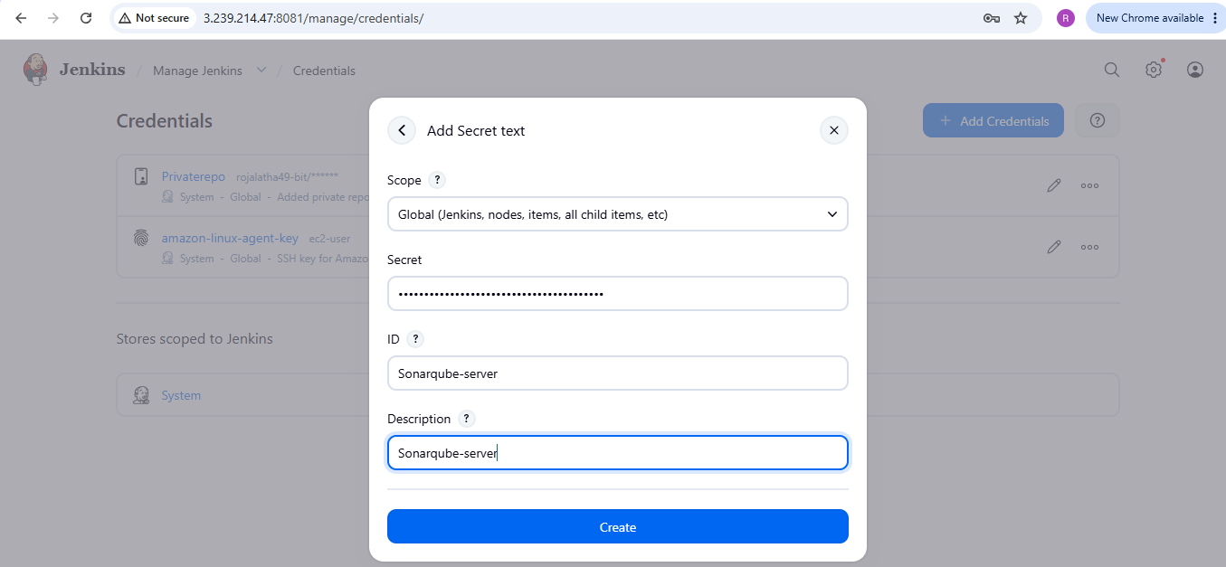

Secret key is added
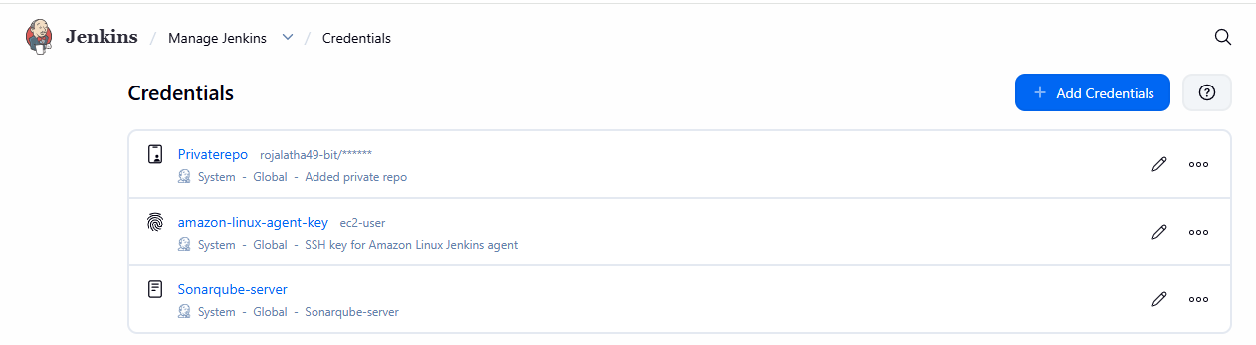

Now go to Jenkins Dashboard, Manage Jenkins, system and sonarqube server
Add Sonarqube URL and Authentication token and click on save
Thus successfully integrated Sonarqube with Jenkins
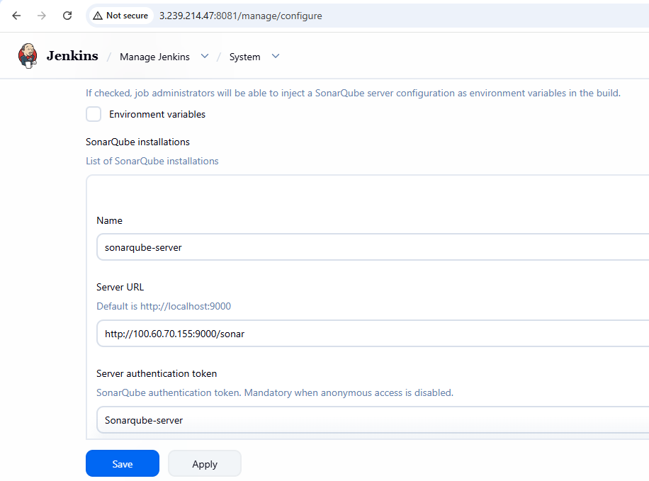
- Now we need to have a mechanism on Jenkins server which will help us to push the reports to sonarqube. Whatever reports are generated on Jenkins server should be sent to sonarqube.
- To acquire that we create Sonar scanner agent that is responsible to push the generated reports to sonarqube-server
- So we have to install sonar scanner on Jenkins server.
- Unzip the extracted URL and rename it

Set sonarqube server details in sonar scanner property file which tells sonar scanner that this is my server push all the properties into it.
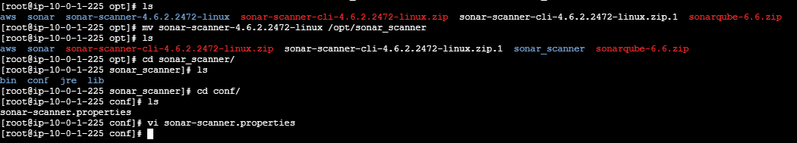
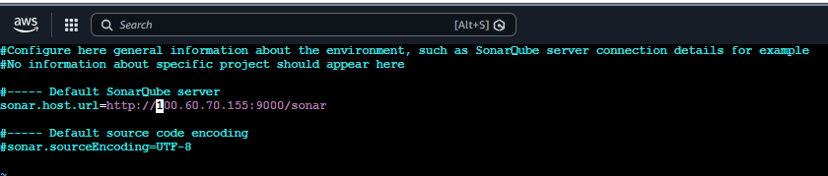

Configure SonarQube scanner home path

- Manage Jenkins> Global Tool Configuration > SonarQube Scanner
- Name : sonar_scanner
- SONAR_RUNNER_HOME : /opt/sonar_scanner

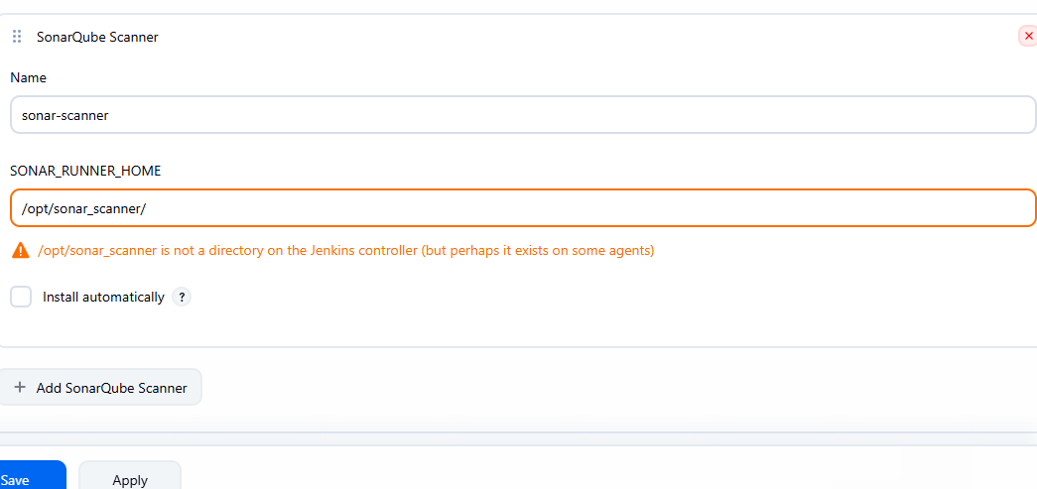

Now we have to tell jenkins job that go to particular scanner and check for the reports.

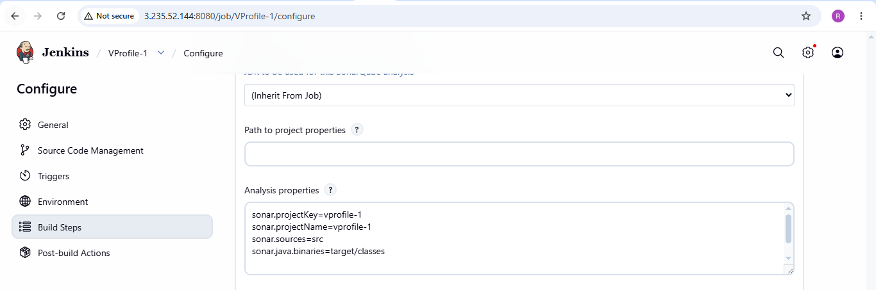
Click on build job and see that job is successfully executed and below is the console output
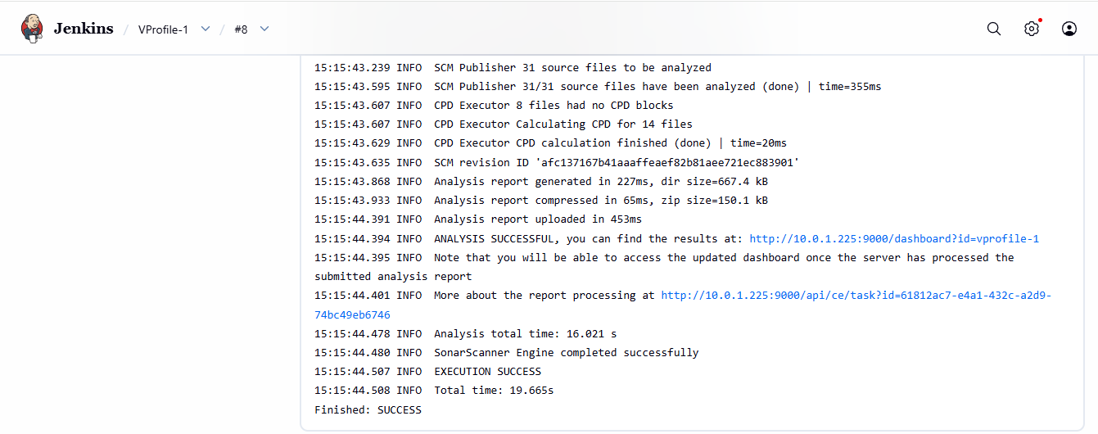
Project is successfully pushed to sonarqube:
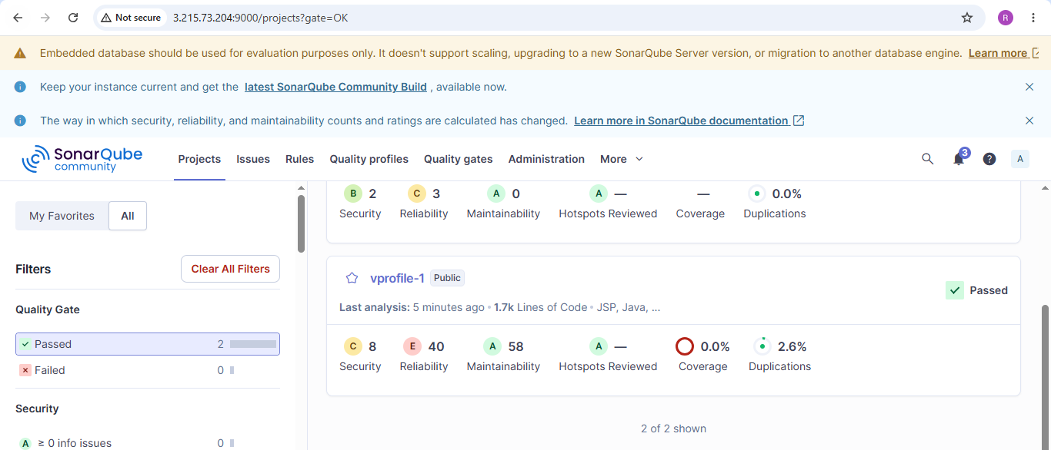

Install the Jenkins Slack plugin
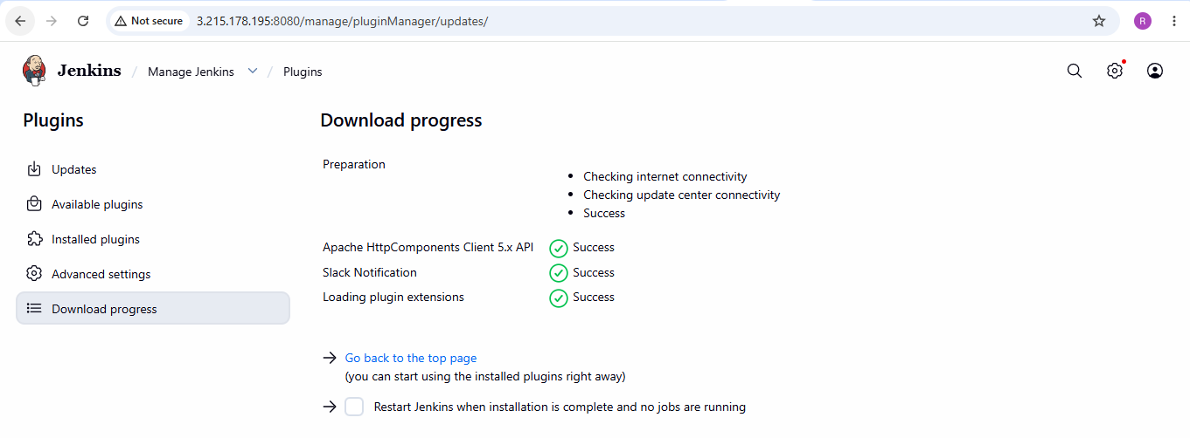
Create the Jenkins Slack credential
Now go back to Jenkins and create a token.
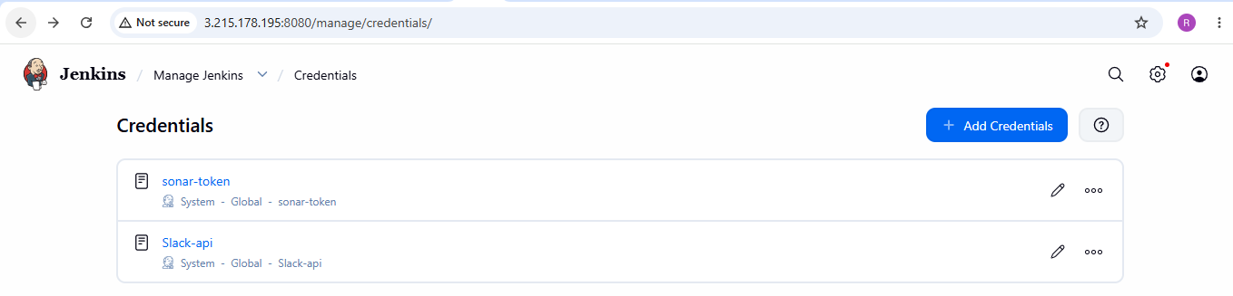

Create a Slack App
Open Slack app in browser that Jenkins can use to send messages.
Create an agent and set channel name and generate token to create credentials in Jenkins.
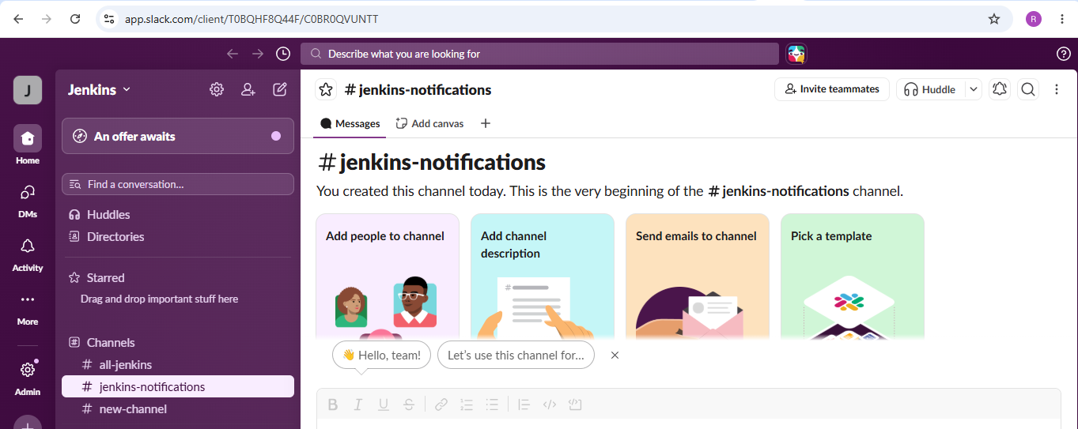

Configure Slack in Jenkins
Now go to: Manage Jenkins → System
Scroll down until you find: Slack Notifications
You'll see fields similar to:
Workspace
Credential
Default channel
Fill the details and click on save.

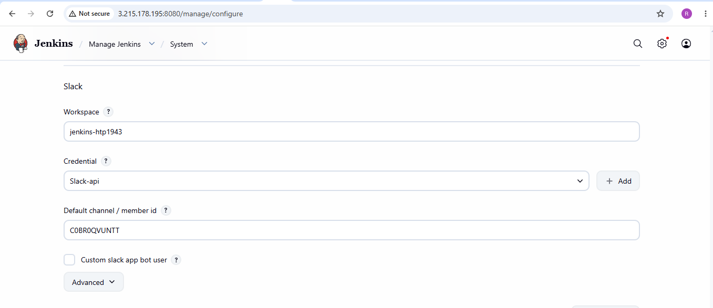

Verify the notification sent to slack:
Now open your Jenkins and click on build job.
Verify the notifications sent to slack when the job is build.

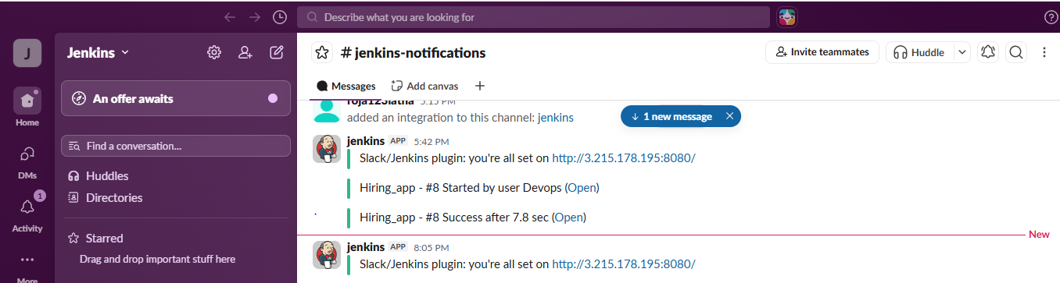

2. Create one Jenkins job using the below code and create three stages.
- stage1: Git clone to download the source code.
- stage2: Sonarqube Integration to check the quality of code.
- stage3: Slack Integration to send the alerts to slack.
Source Code: https://github.com/betawins/hiring-app.git
Step 1: Clone the given repository:
On Jenkins console, create new job and configure with git repo URL.
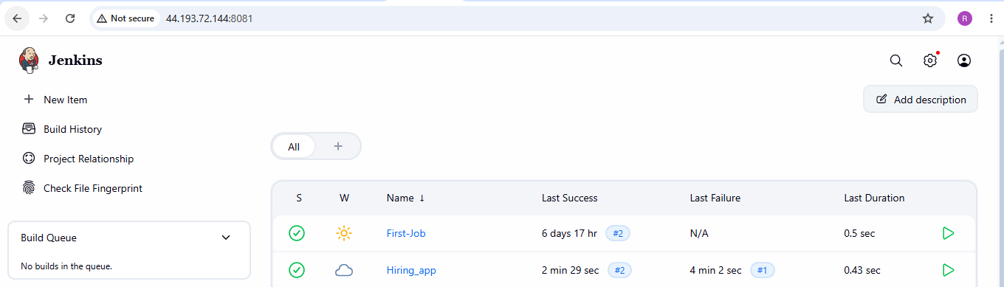

Click on build job and see that job is successfully executed and below is the console output
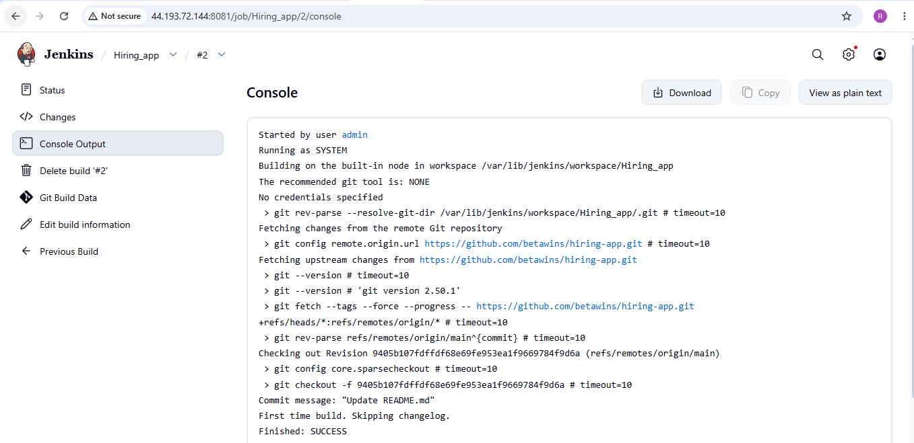
Install Java on Jenkins server.
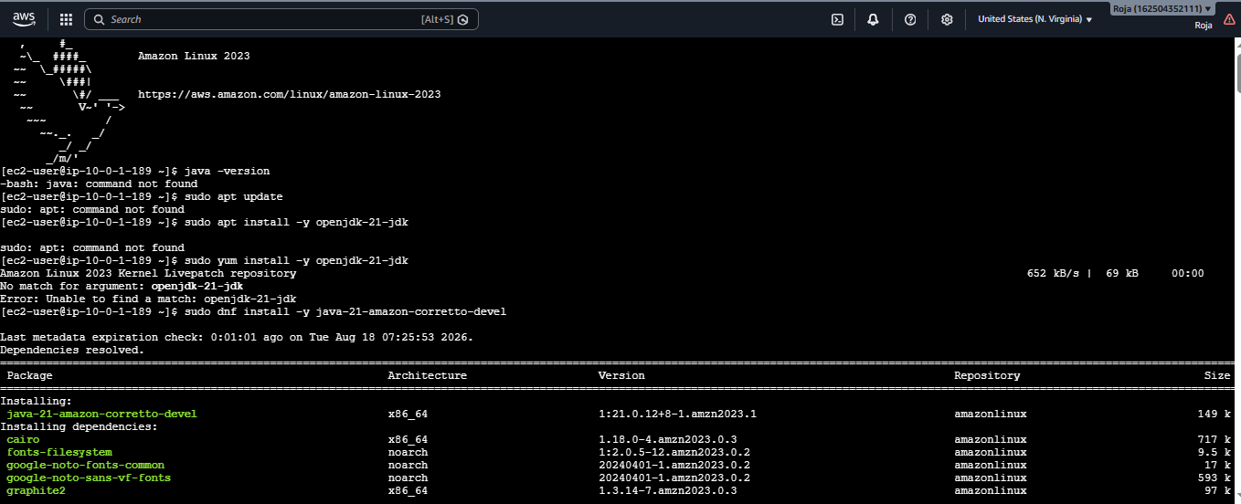
Installed Git on Jenkins server:
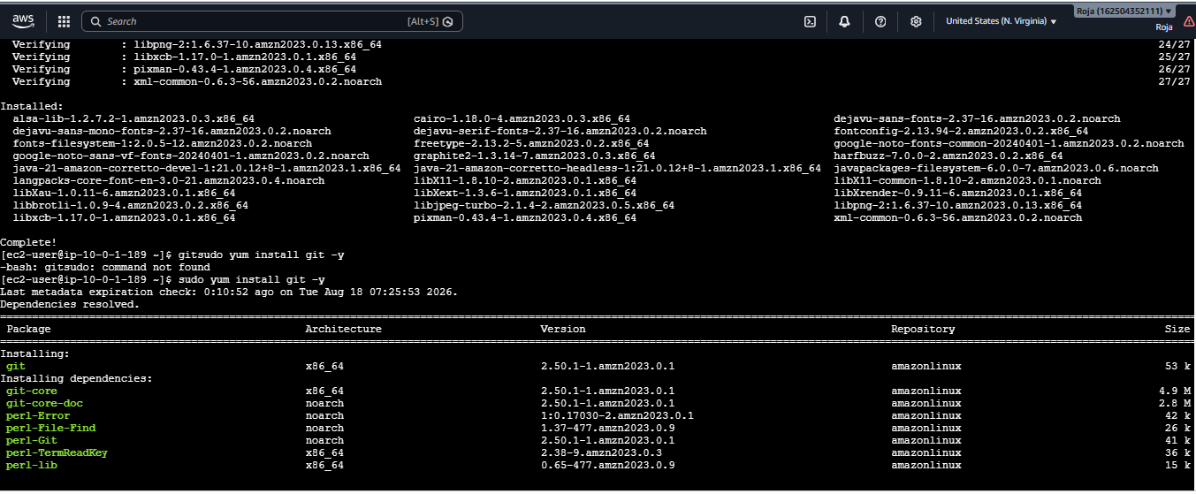
Started Jenkins and Verified the status of Jenkins
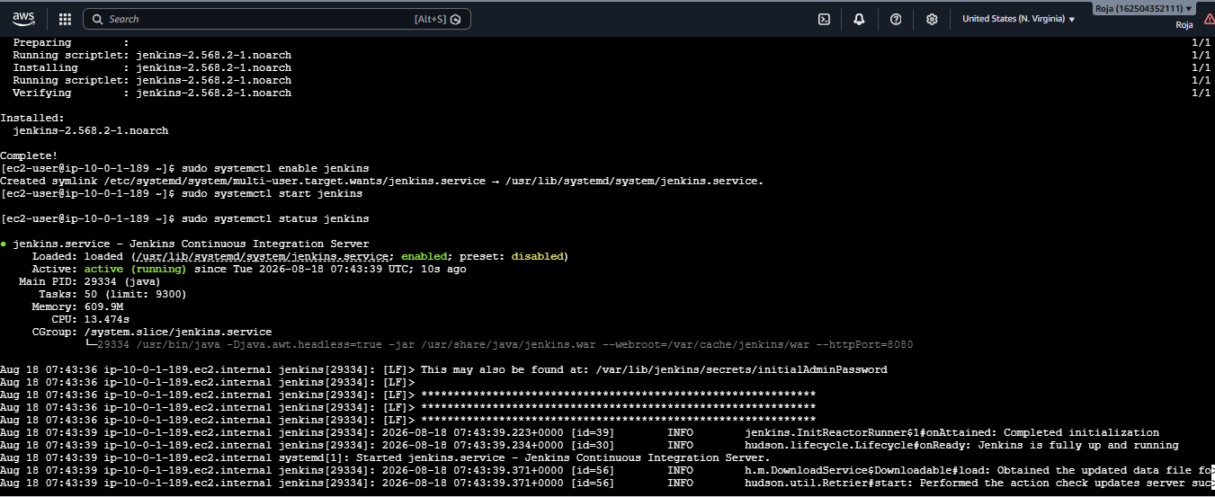
Also installed sonar-scanner and verified its version:
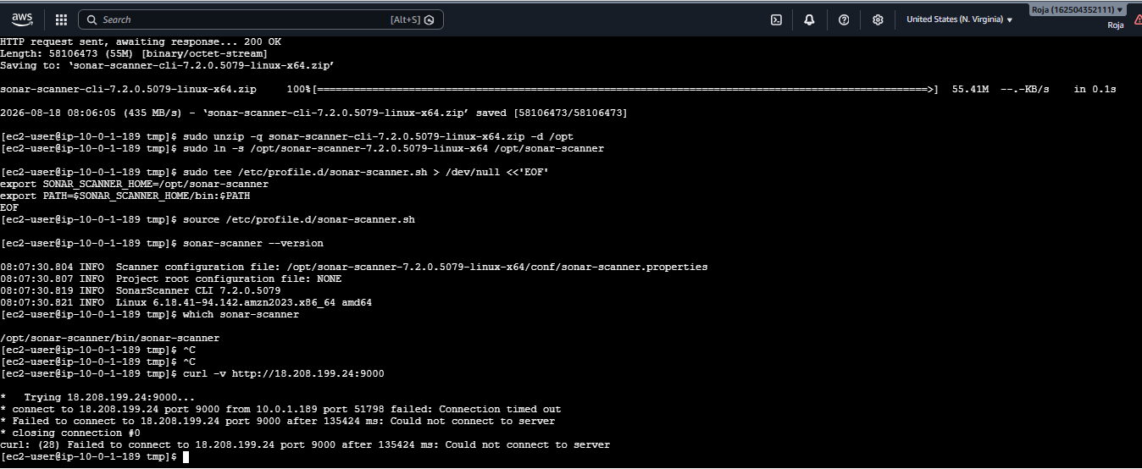
Project is successfully pushed to sonarqube:
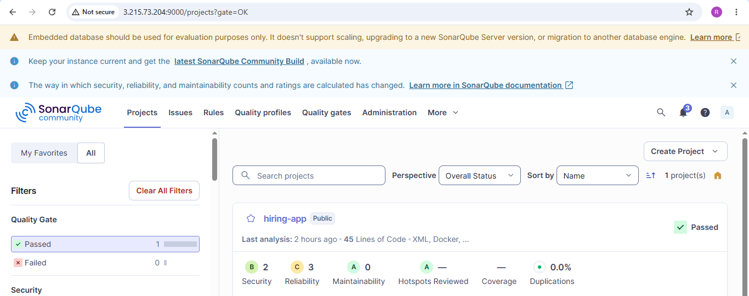
Install the Jenkins Slack plugin
Create the Jenkins Slack credential
Now go back to Jenkins and create a token.

Create a Slack App
Open Slack app in browser that Jenkins can use to send messages.
Create an agent and set channel name and generate token to create credentials in Jenkins.

Configure Slack in Jenkins
Now go to: Manage Jenkins → System
Scroll down until you find: Slack Notifications
You'll see fields similar to:
Workspace
Credential
Default channel
Fill the details and click on save.

Verify the notification sent to slack:
Now open your Jenkins and click on build job.
Verify the notifications sent to slack when the job is build.
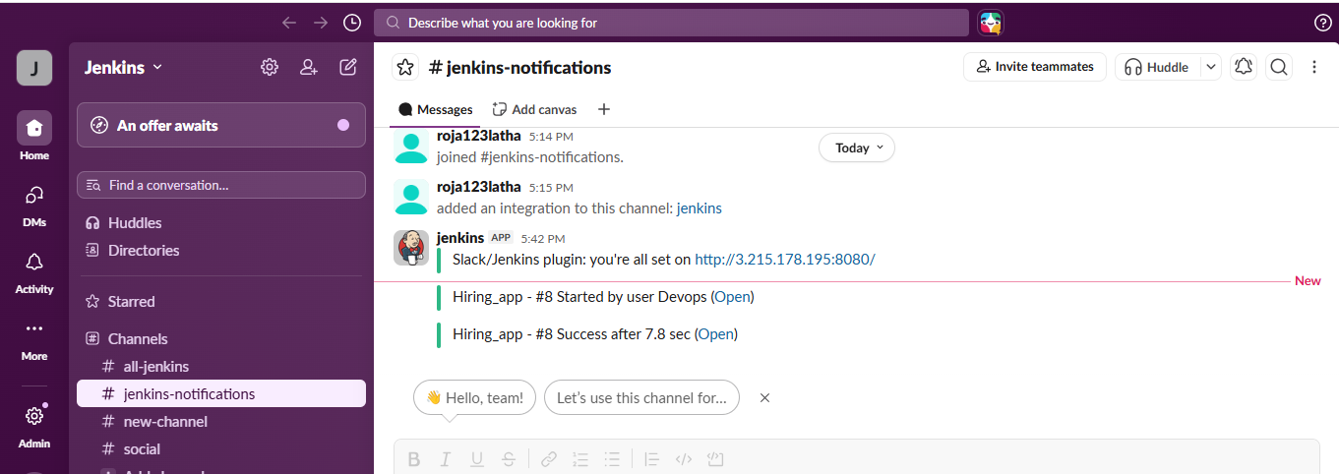

a7vc9twzZ7M8pakti05z4wUD

